Gaining Weight

Apparatus
two bathroom scales

Action
A student stands on one of the scales. They then see if they can change the reading without touching anything else. They should try to hold the new reading. They then try to change the reading while holding on to a friend. They should note the direction of the force that they exert on their friend, and the direction of the reaction force exerted on them. They should also note the direction of change of the reading on the scale.
With one foot on each scale the students can experiment with shifting their weight distribution. They should attempt to draw free body diagrams showing the forces acting on themselves and on the scales.

The Physics
When the student is not touching anything else the only external forces acting on them are gravity and the normal force. They can change the reading on the scale momentarily by bouncing up and down, but they cannot change and hold the reading. When the students can experience an additional external force, by pushing up or down on a friends arm, they can change and hold the reading.
If they push down on the other student they experience a reaction force upwards, which decreases the force acting on the scales and it reads a lower weight. The forces acting on the student are now gravity, the normal force due to the scales, and the external force due to the other student. By pushing upwards against the other student they can increase the weight shown on the scale.  With one foot on each scale they can vary the proportion of their weight on each scale, but the sum of the two readings should be constant. | 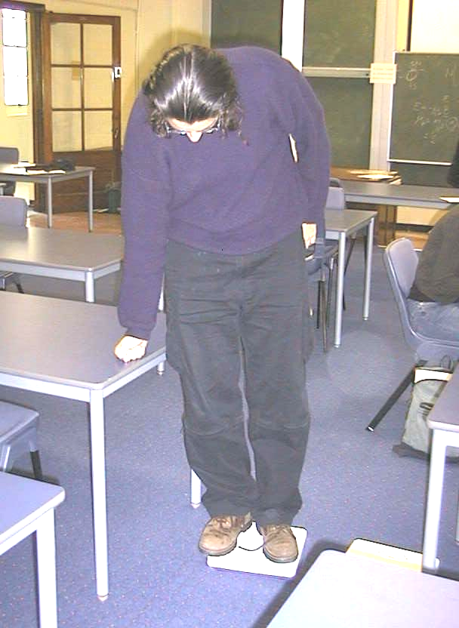

The student decreases his weight (apparently) by pushing down on the table.

Accompanying sheet

Gaining Weight

Stand on a scale.
Can you change the reading without touching anything else?
Can you hold the new reading?

Can you change and hold the new reading while hanging onto a friend?
What direction do you apply the force in to increase the reading?
What about to decrease it?

Draw a free body diagram showing the forces acting on you and on the scale.

