Maps

Apparatus
street directory, other maps, e.g. campus maps

Action
The students examine the maps and look for examples of the use of vectors. They choose a starting and finishing point on a map, for example the university and the local shops, and find a vector which represents the displacement when travelling from one to the other.

The Physics
Vectors are used to define positions on the maps via a letter/number grid. Most maps will also show a vector pointing north to define compass directions on the map, and sometimes vectors showing both true north and magnetic north. The vector representing displacement can be written as x North + y West, or in terms of the angle.

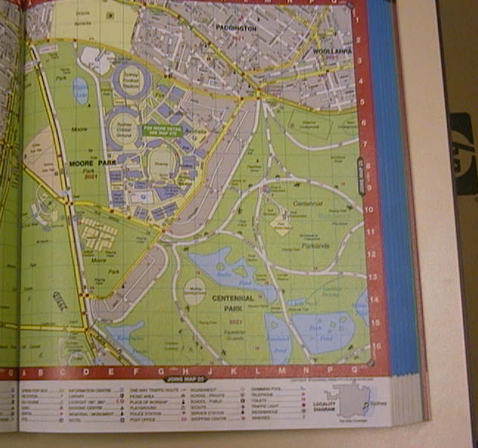

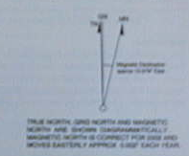

Accompanying sheet

Maps

Examine the maps.

How many examples of the use of vectors can you find?
(There are at least two.)

Choose a starting point and an end point.
Write down the vector that describes the displacement
from the starting point to the end point.

