Marble Ejecting Trolley

Apparatus
projectile launcher with wide barrel pointing directly upwards, mounted on trolley, marbles or other small projectiles

Action
The students launch a marble from the launcher while it is stationary. They then predict what will happen if the trolley is moving while a marble is ejected. They roll the trolley forwards, and eject a marble to test their predictions. Note that this should be done by giving the trolley a gentle push and then launching so that its velocity is as close to constant as possible. Alternatively, a motorized trolley, such as the base of a battery powered toy car or train, can be used.

The Physics
The marble will have a constant horizontal velocity (neglecting air resistance) equal to that at which it was launched, i.e. the horizontal velocity of the trolley. Its vertical velocity will be v_{initial} – gt. These components are independent. Hence in the horizontal direction the trolley and marble have the same displacement and the marble falls back into the barrel of the launcher. This is also a good activity to introduce reference frames. In the trolley’s frame the marble has zero horizontal velocity, in the frame of the student observers it has some velocity, v > 0.

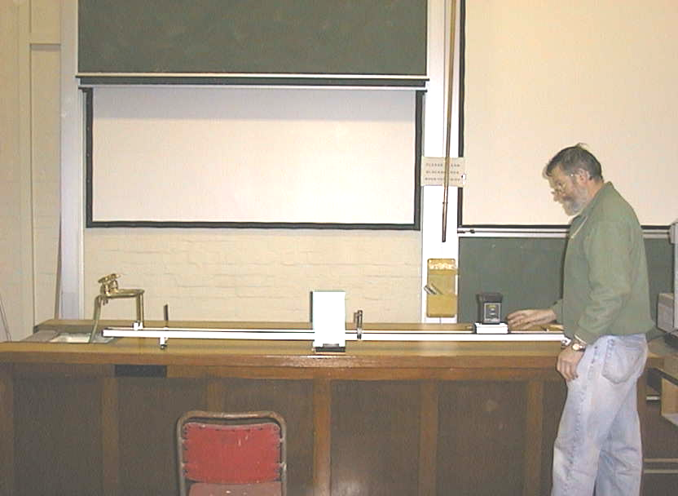

Lecture demonstration coordinator (University of Sydney) demonstrates the marble ejecting trolley.

Accompanying sheet

Marble Ejecting Trolley

With the trolley stationary, eject the marble.

What will happen if it is moving and a marble is ejected?
Check your prediction.

Warning:
Do NOT stand in front of the trolley. Do not look into the barrel!

