Newton’s Cradle – Different Balls

Apparatus
two sets of Newton’s cradle with different types of balls, one with lead balls and one with steel balls

Action
The students swing one of the balls out and observe what happens when it is released and collides with the next ball along. They should compare the behaviour of the two sets.

The Physics
Steel balls have almost elastic collisions, in which both kinetic energy and momentum are conserved. When the ball is released and swings back it stops, and the ball at the far end swings out to almost the same height as the first ball was lifted to. This is due to a series of very rapid collisions between the balls.
The lead balls have inelastic collisions in which only momentum is conserved, so the ball at the far end swings out very little as not much energy is transferred. This is because lead is softer and deforms on impact, absorbing the kinetic energy and dissipating it as thermal energy.
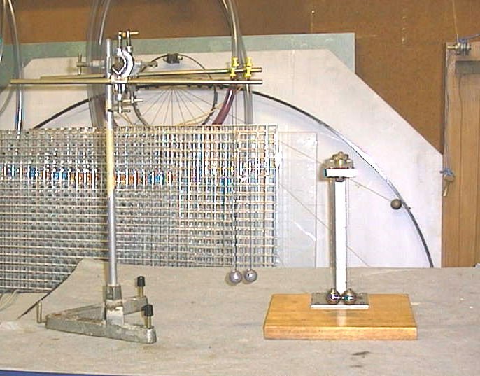

Newton’s cradle with lead balls and
steel balls.

Accompanying sheet

Newton’s Cradle – Different Balls

Experiment with the two sets of Newton’s cradle.
Why do they behave differently?

Is energy being conserved?
What about momentum?
In which set is the collision an elastic one? Explain your answer.

