Pendulum

Apparatus
simple pendulum, such as a ball on a string suspended from a retort stand

Action
The students swing the pendulum and determine how the kinetic and gravitational potential energy of the bob vary in time. They identify the positions at which kinetic energy is a maximum and minimum, and where gravitational potential energy is maximum and minimum. For the “motion” worksheets the students determine where the velocity and acceleration are a minimum and maximum.
For the Work, Power and Energy worksheets the students look at energy changes and determine which forces are doing work.

The Physics
At the lowest point of its motion, kinetic energy is maximum and potential energy is minimum. This is where the velocity is a maximum. At the highest point of its motion, kinetic energy is minimum (i.e. zero) and potential energy is maximum. The acceleration is a maximum at the end points of the swing, and a minimum (zero) in the middle, at the lowest point.
The forces acting are gravity, tension and friction. Tension does no work because it is always at right angles to the direction of motion. Both gravity and friction do work, although the only net work done on the pendulum in a complete swing is done by friction slowing the pendulum down.
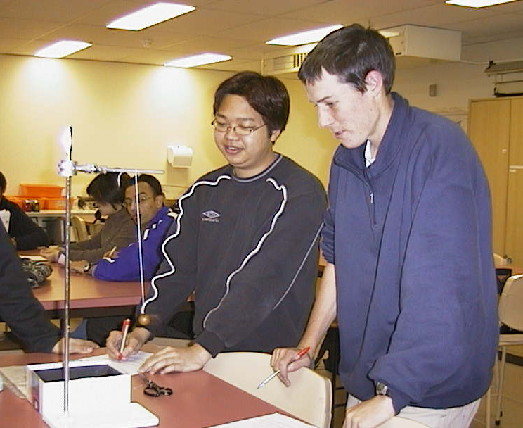

Students at the Australian Catholic University observing energy changes in a pendulum.

Accompanying sheets

Pendulum

At what position is the kinetic energy maximum?
Where is it minimum?

At what position is the potential energy maximum?
Where is it minimum?

Draw energy bar graphs for the pendulum at different points in its swing.

Pendulum

What forces are acting on the pendulum?

What work is being done on the pendulum?

What forces are doing the work?.

