Power

Apparatus
various small appliances with power ratings shown, for example hair dryer, jug, heater, toaster etc

Action
The students examine the various appliances and determine how much power they use. They should try to describe the energy conversions which take place when the devices are operating.

The Physics
The power listed on the device is the rate at which it converts electrical potential energy into other forms of energy. A hairdryer converts electrical potential energy into heat and kinetic energy. Most appliances convert a lot of electrical potential energy into unwanted heat. In general devices which use motors, such as hairdryers, use more power than those that simply heat, such as toasters or jugs.

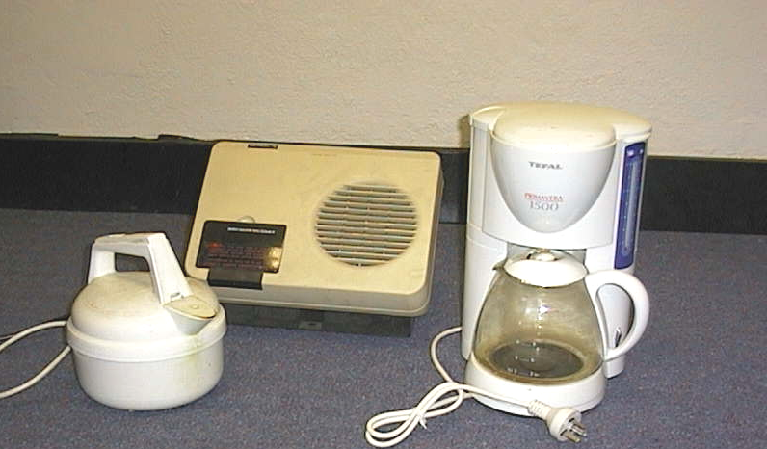

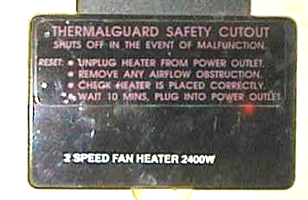

Selection of appliances and detail from fan heater showing power rating.

Accompanying sheet

Power

Examine the various appliances on display.
Which uses the most power?
Which uses the least?

At what rate do they turn electrical energy into other forms of energy?

What energy conversions are taking place when these appliances are working?

