Projectile Launcher

Apparatus
projectile launcher which can be angled, soft projectiles
A simple launcher can be made using a piece of pipe and spring with trigger to release the spring. Alternatively a toy gun with spring which can be mounted on a retort stand and angled can be used.

Action
The students experiment with firing the projectiles with different launch angles, and see what angle gives them the maximum range.

Note: Students should be cautioned to keep clear of the projectile launcher when firing, and never look down the launcher.

The Physics
Provided initial speeds are the same, the launch angle for maximum range is 45º. To achieve maximum height the projectile should be launched directly upwards so that its initial vertical velocity is a maximum.
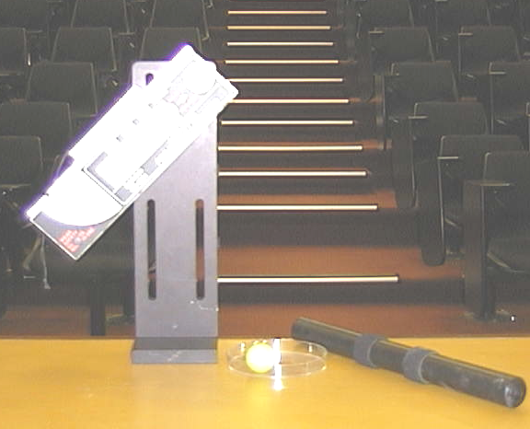

Accompanying sheet

Projectile Launcher

What is the angle of launch corresponding to maximum range?

What is the angle of launch corresponding to maximum vertical height?
.
Warning:
DO NOT stand in front of the launcher!!!!!!!!

