Rotation Platform

Apparatus
rotation platform, such as a small turntable from a record player, with some way of turning it steadily, small objects, chalk dust

Action
The students dip the base of the objects in chalk dust, and place them on the rotation platform. They then turn the platform steadily, gradually increasing speed, and observe when and how the objects slide off.

The Physics
The speed of rotation, distance from the centre and coefficient of friction, μ, affect slipping, but not the mass. The objects will slide off at a tangent to the curve, in the direction of their velocity vector. At the edges of the platform the linear acceleration is greatest, hence objects are most likely to slip off when close to the edge.
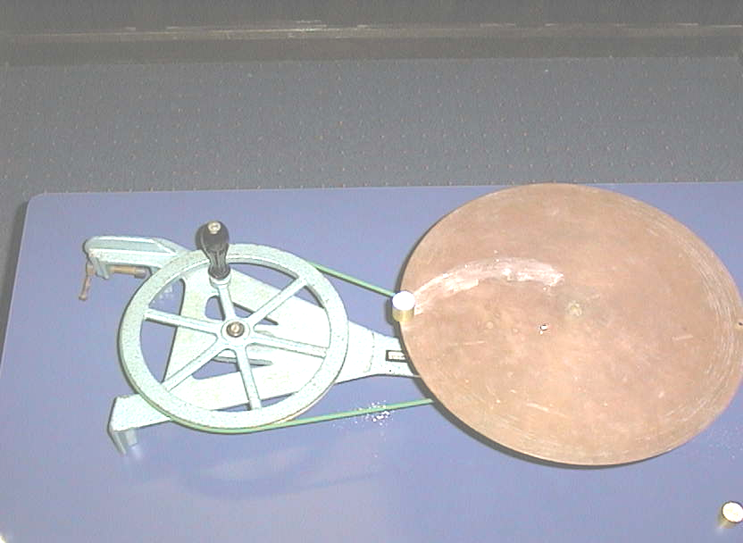

Rotation platform showing chalk mark of object about to slip off.

Accompanying sheet

Rotation Platform

Put some chalk dust on an object and place it on the turntable.

Turn the handle at a steady rate, then gradually increase the angular velocity.
What happens to the object on the turntable?
Describe the path that it follows?

Try placing the object in different positions on the turntable.
What happens?

