Shoes

Apparatus
selection of shoes for different purposes, for example golf or soccer shoes with spikes for grip, walking shoes, dress shoes with slippery soles, dancing shoes, etc

Action
The students examine the soles of the shoes and consider why different shoes have different soles.

The Physics
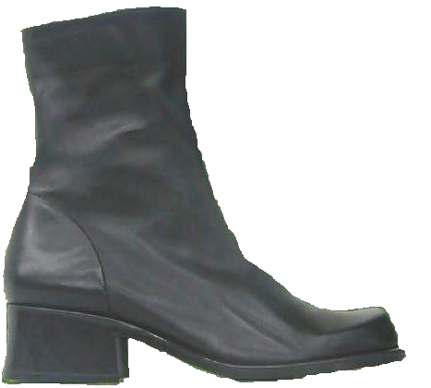
Some activities, such as soccer, require a lot of grip as they are played on slippery surfaces. Normal shoes will not provide enough grip as the coefficient of friction between shoe and muddy ground will be too low. This is less important in walking as the accelerations are usually not as great, hence the coefficient of friction does not need to be so large. Dancing shoes need to be able to slide, but not too much. Hence they usually have smooth soles, to which talc is applied to increase the coefficient of friction between shoe and floor.

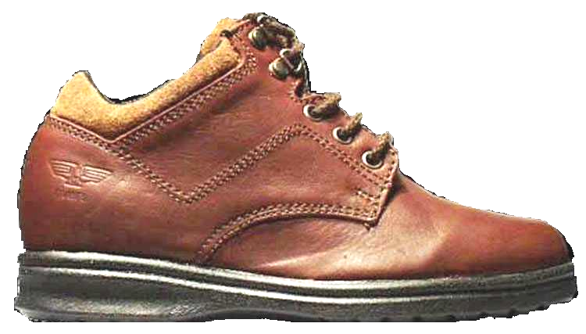

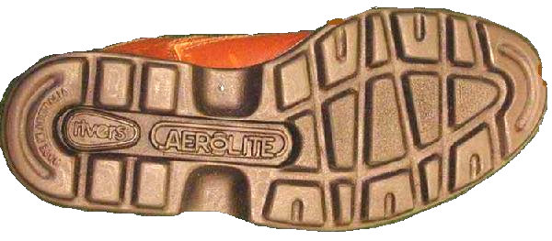

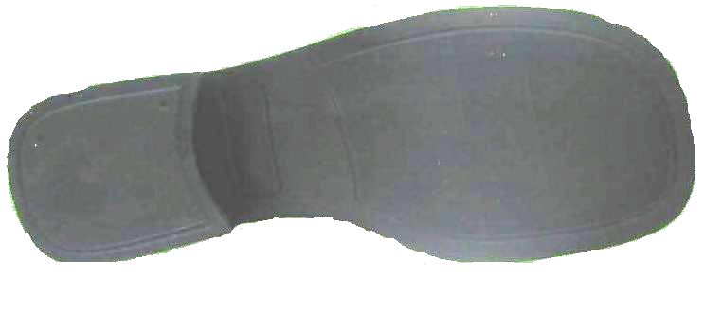

Accompanying sheet

Shoes

Why do some of the shoes have spikes?
If spikes give you more grip, why don’t hiking or running shoes have spikes?

Why do some of the shoes have smooth soles?
How can the coefficient of friction between
these shoes and the floor be increased?

