Solar Panel and Electric Circuit

Apparatus
small solar panel connected to small motor or light, desk lamp

Action
The students hold the solar panel beneath the desk light and observe the light or motor. They track the energy changes from the desk light through the circuit. It is helpful to draw a flow chart showing the energy conversions taking place.

The Physics
Energy as light is converted to electrical energy by the solar cell which is then converted to kinetic energy by the motor or back to light by the globe. Some energy is also converted to thermal energy at each step.
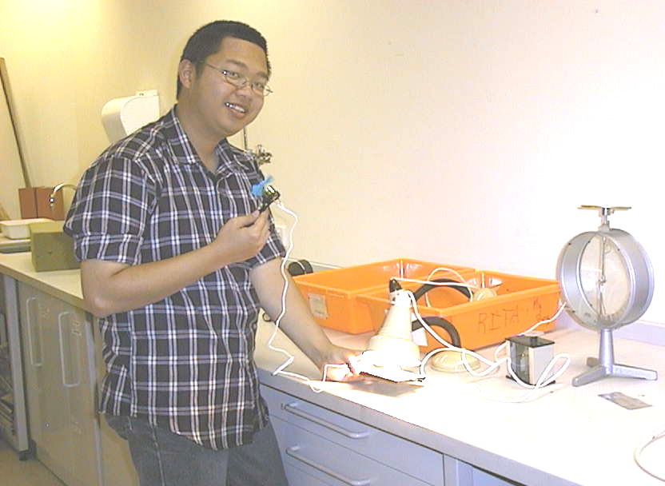

A student at the Australian Catholic University using the light energy from a desk lamp to run a small fan to cool himself.

Accompanying sheet

Solar Panel and Electric Circuit

Trace the energy conversions and identify
which ones are "not useful" and which are.

Think of a case where this "not useful" energy may be useful.

Trace energy transformations that occur as water stored in a dam,
supplies energy to a hydro-electric power station,
which supplies energy to turn on an appliance at home.

