Tennis Racquet

Apparatus
tennis (or squash) racquet, tennis balls

Action
The students hold the tennis racquet in one hand and drop a ball onto it, observing how high the ball bounces from the racquet. They then hold the racquet with the handle firmly pressed against a horizontal surface (such as the floor or desktop). This is quite difficult, and works best when the handle is stood or sat on. They then drop the ball onto the racquet from the same height above the racquet as previously, and observe how high it bounces this time.

The Physics
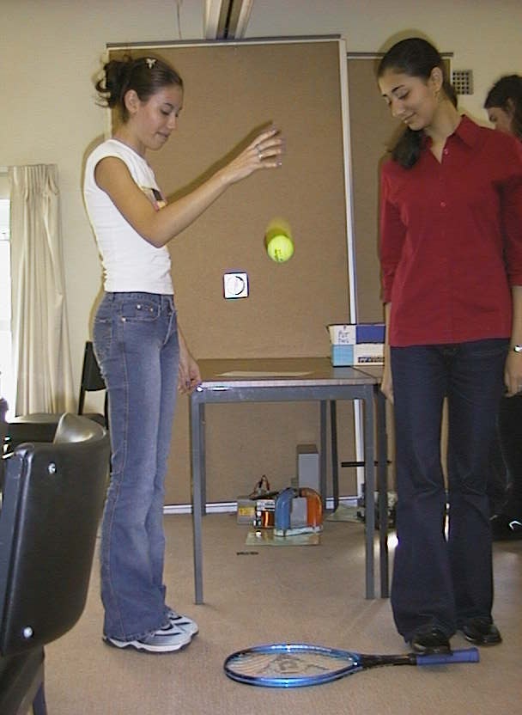
Kinetic energy from the ball is transferred to the racquet strings and through the handle to the wrist or hand of the person holding the racquet. When the racquet is held loosely it vibrates, dissipating energy. When it is held firmly so that it cannot vibrate there is less energy lost from the strings to the handle. Hence more energy is stored in the strings and returned to the ball, allowing it to bounce higher than when the handle is loosely held.

Students at the University of Sydney experimenting with the tennis racquet.

Accompanying sheet

Tennis Racquet

Hold the racquet out horizontally and drop a ball onto it.
How high does the ball bounce?

Hold the handle still by stepping on it.
Drop a ball onto it from the same height as before.
How high does the ball bounce now? Why?

