The Human Body

Apparatus
set of diagrams showing some of the pivots (joints) in the human body and the muscles which exert torques around them, see below for examples

Action
The students examine the diagrams, and their own joints. They should identify the pivots, forces and directions of forces acting at the joints.

The Physics
Several joints and the muscles/tendons which exert torques on them are shown.
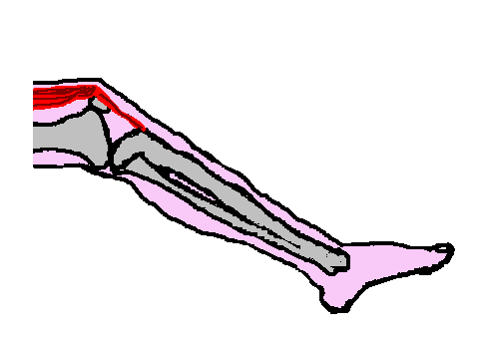
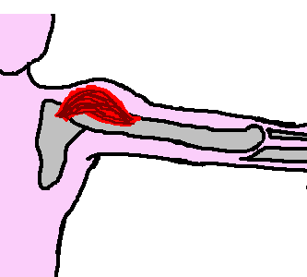
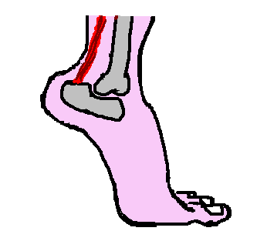
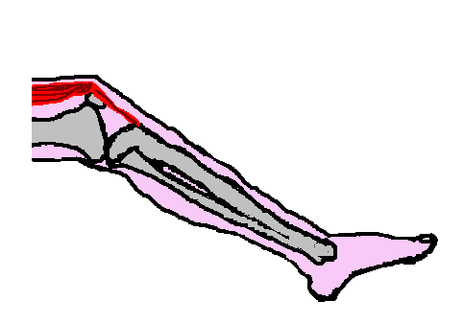
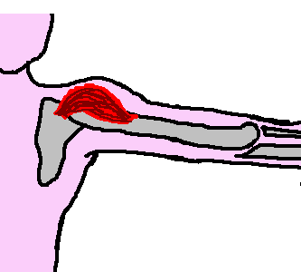
tibia
patellar tendon
deltoid
humerus
Achilles tendon
tibia
pivot
W_{leg}
W_{foot}
T_{tendon}
pivot
N_{ground}
W_{body}
T_{tendon}
pivot
W_{arm}
T_{deltoid}

Accompanying sheet

The Human Body

Identify the pivots in the diagrams.
What muscles act to produce a torque around these joints?
Where do the forces act, and in what direction?

You may want to compare with your own joints.

