Velocities

Apparatus
tape measure, stop watches, masking tape

Action
The students use the tape measure and masking tape to place two lines of tape on the floor some set distance (e.g. 10 metres) apart. They then take turns trying to walk from one line to the other with positive and negative velocities, and at a given magnitude of velocity. They will need to define in advance which direction is positive and which negative. They should consider how they define positive, whether with reference to the room (e.g. towards the door/window/blackboard/etc is positive) or with reference to themselves (the way I face is positive). They should recognise that defining direction relative to the room is more useful than defining in terms of self, as they turn around frequently.

The Physics
Velocity is displacement per unit time. Most people have a step length a bit less than 1 m, usually around 70 to 80 cm, so 1 m.s⁻¹ is equivalent to a little more than one step per second. To move with a negative velocity they must walk in the negative direction, which is not equivalent to walking backwards in the positive direction (unless they have defined positive as the way they are facing).
It is interesting to also get them to consider their acceleration, and how they can have a positive velocity but a negative acceleration etc.
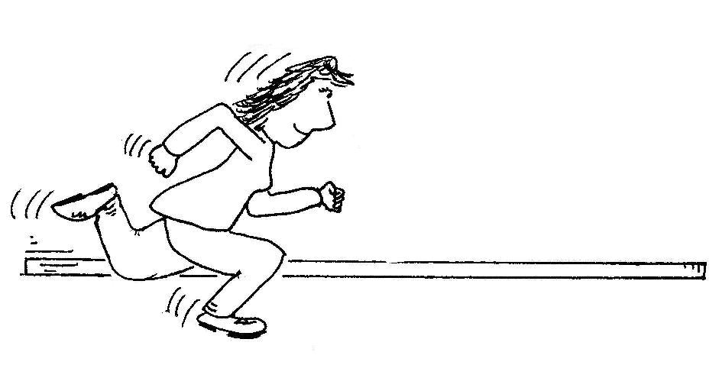

Accompanying sheet

Velocities

Try to walk from one marker to the other at 1 m.s⁻¹.
Get someone to time you so that you can check how fast you are going.

Now try to go at 0.5 m.s⁻¹ and 3 m.s⁻¹.

What do you need to do to move at –1 m.s⁻¹?

