Breaking Chalk

Apparatus
box of chalk

Action.
The students attempt to break the chalk by compressing it, stretching it, bending it and twisting it. They should comment on the strength of the chalk to withstand different types of applied force.

The Physics
Most materials are better able to withstand compressive and tension forces than shearing or torsional forces. This is the reason bones are generally broken due to twisting or bending, and very rarely due to compression.
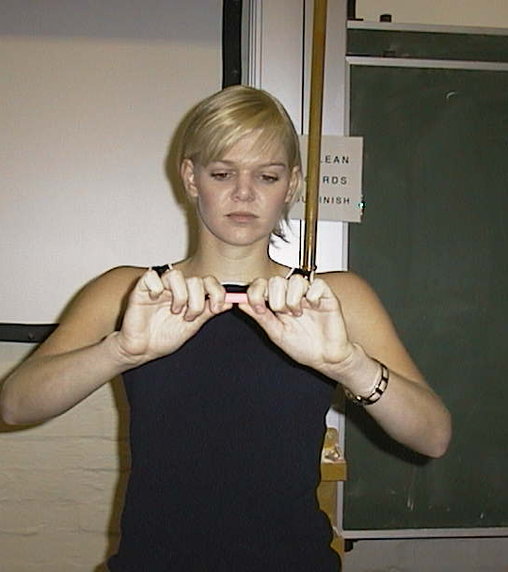
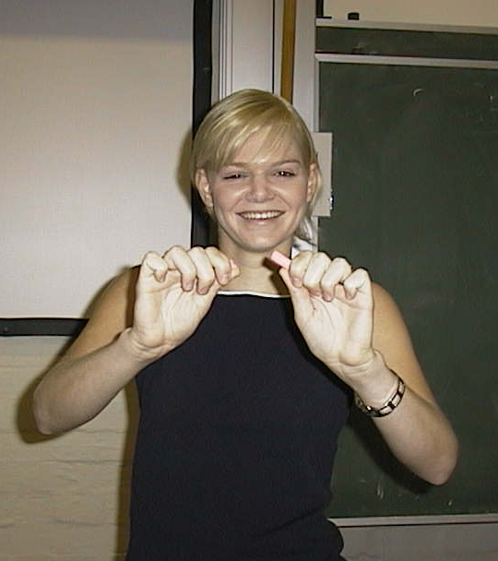

Hannah (University of Sydney) discovers that chalk is weak to bending forces.

Accompanying sheet

Breaking Chalk

Try to break the chalk by compressing it.
Can you break it by stretching it?

What about bending or twisting?

How do you think most bone fractures occur?

