Buoyant Force I

Apparatus
An object (preferably dense, e.g. a metal weight) suspended from a spring balance.
A container of water.

Action
The students compare the weight of the metal weight using the spring balance when the metal weight is in air and when it is submerged in water. They should explain why the readings on the spring balance are different.

The Physics
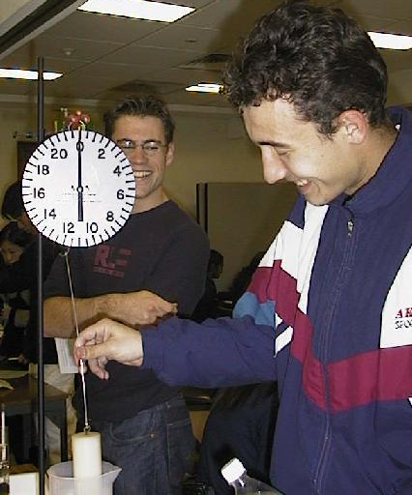
The object will weigh less in water than air because water is more dense than air and hence the buoyant force is greater. In both cases F_{B} + T = mg, and the scale measures the tension, T. F_{B} is greater in water, hence T is less.

Students at the University of Sydney measuring the buoyant force on an object.

Accompanying sheet

Buoyant Force I

An object is suspended from a spring balance.

What happens to the reading on the spring balance
when the cylinder is immersed in water? Why?

Draw a diagram showing the forces acting on the object.

