Crystal Structures

Apparatus
models showing different crystal structures.

Action
The students observe the crystal structures, and try to identify the basis cell and the coordination number of the crystal.

The Physics
The basis or unit cell is the smallest repeated cell in a crystal. The coordination number, CN, is the number of nearest neighbour atoms for each atom. Some examples of unit cells are shown below.

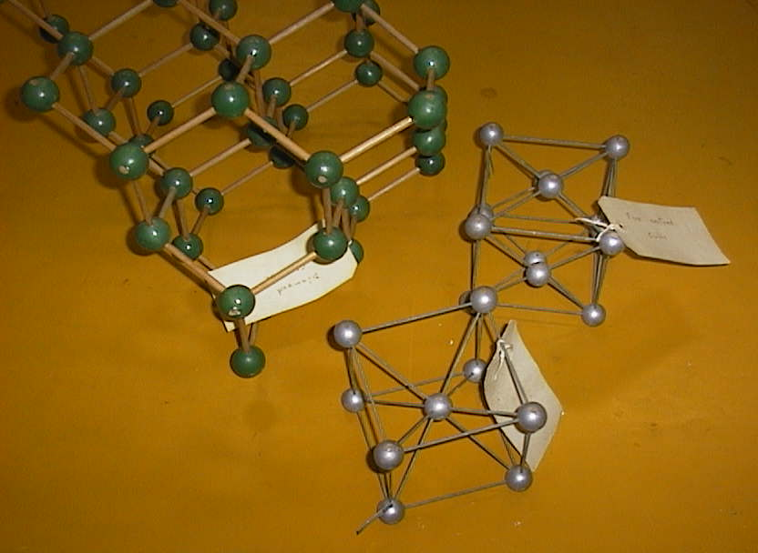

face centred
cubic, CN 12
simple cubic,
CN 6

body centred
cubic, CN8

Accompanying sheet

Crystal Structures

Can you identify the unit cell for the crystal structures shown?

What is the coordination number for each lattice?

