Hot Honey

Apparatus
clear jar with some honey in it, and scale marked on, with well sealing lid, hot water in container larger than the jar, icy cold water in container larger than the jar

Action
The students observe the height or volume of honey in the jar. The students tilt the jar and observe how long it takes the honey to run from one end of the jar to the other.
The jar of honey is heated in the hot water and the volume is again noted. The students observe how long it takes the hot honey to run from one end of the jar to the other. The students try to determine whether there is necessarily a relationship between density and viscosity.
The jar should be placed in the cold water after this so that it cools enough for other groups to repeat the observation quickly.

The Physics
The density of the honey changes negligibly when it is heated, the volume does not change and the jar is sealed so the mass of honey has not changed. The hot honey is considerably less viscous than the cold honey, and runs very quickly from one end of the jar to the other.
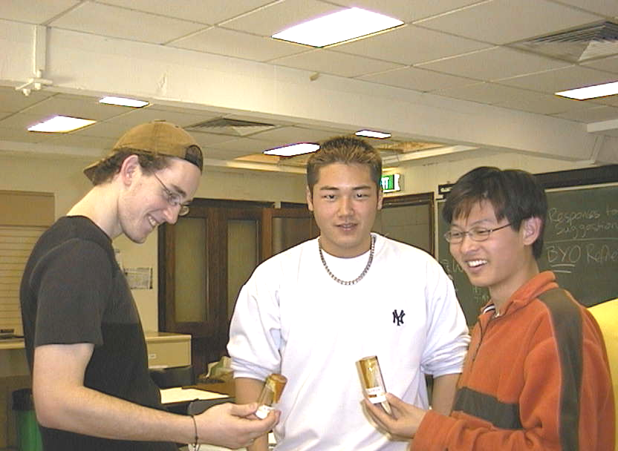

Students at the University of Sydney observing hot runny honey and cold (not-runny) honey.

Accompanying sheet

Hot Honey

Observe the volume of honey in the jar.
Tilt the jar and see how quickly the honey flows.

Heat the jar in the hot water.
Has the volume changed? Has the density changed?
What about the viscosity?

What can you conclude about the relationship between viscosity and density?
When you are done, cool the honey in the cold water for the next group.

