Hydrometers

Apparatus
three or four simple hydrometers - either commercially produced or lengths of wood with a weight at the end and a calibrated scale, beakers containing liquids of different densities

Action
The students use the hydrometers to measure the densities of various fluids. They try to explain why the scale is marked from high densities at the bottom to low densities at the top.

The Physics
The buoyant force is equal to the weight of fluid displaced, which is equal to the weight of the object displacing the fluid if it is floating. Hence the buoyant force on any floating objects with the same mass, is the same regardless of the fluid they are floating in. The more dense a fluid the less of the fluid will be displaced to balance the weight of the hydrometer. Hence a hydrometer sits higher in more dense fluids, so the large numbers are at the bottom, and the small numbers at the top.
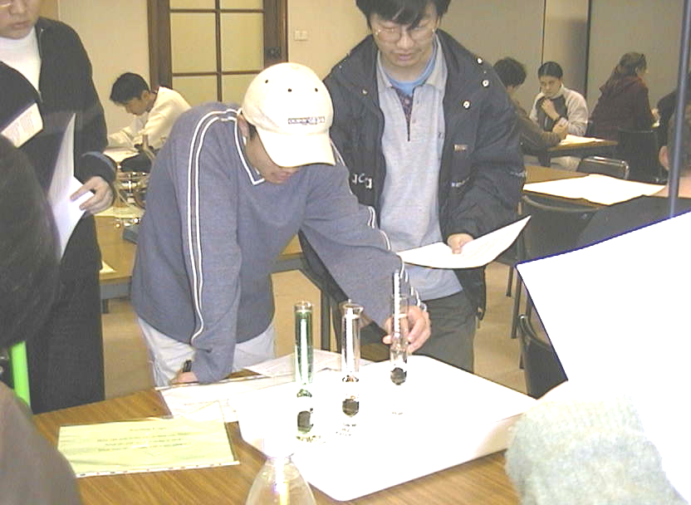

Students at the University of Sydney looking at hydrometers suspended in cylinders containing three different fluids.

Accompanying sheet

Hydrometers
Observe the heights at which the hydrometers float in the different liquids.

Is the buoyant force on the hydrometers the same or different?
Why?

Why is the scale on the hydrometer marked the way it is?

