Measuring Fluid Flow

Apparatus
Set of syringes or capillary tubes with different diameters and lengths, water and possibly other more viscous fluids, such as milk, stop watch, small measuring cylinders or beakers

Action
The students time how long it takes some small volume of fluid to pass through the different tubes. They should determine what factors increase and what factors decrease fluid flow.

The Physics
Fluid flow increases with radius of tube (it increases with r⁴), it decreases linearly with length of tube and viscosity of the fluid. It also increases with increased pressure drop along the path. This is important with syringes with plungers which allow you to increase the flow by increasing the pressure.
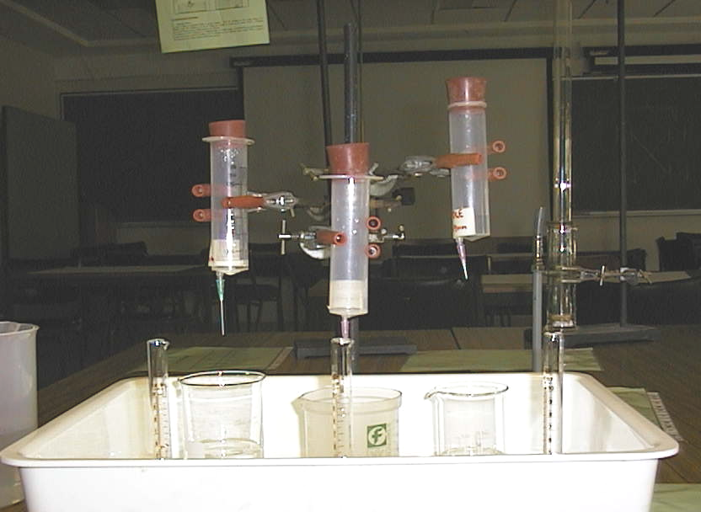

Accompanying sheet

Measuring Fluid Flow

Time how long it takes for a given amount of fluid to
flow through the different capillaries.

How does flow rate vary with diameter?

Does the length of the tube affect the flow rate?

