Pascal's Vases

Apparatus
Set of Pascal’s vases: pipes or vessels of different sizes and shapes attached to a common reservoir at the base.

Action
The students explain why the fluid levels are the same in all the vases. They then apply a pressure to the fluid in one vase and see what happens to the fluid levels in the other vases.

The Physics
An increase in the pressure in one tube will be transmitted to the other tubes, and the liquid level in these tubes will rise. This is possible because the vases are all connected and hence are really a single vessel.

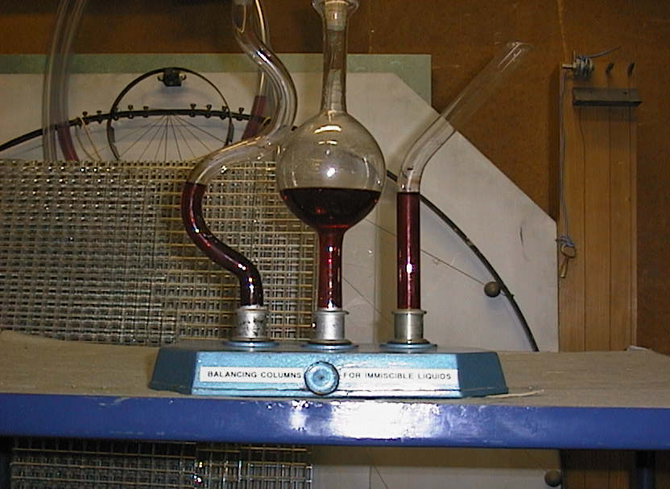

Accompanying sheet

Pascal’s Vases

The bases of the vases are linked to a common reservoir.

Why is the water level the same in each column?

What would happen if the pressure in one column was increased
and the others were still open?

