Rheological Materials

Apparatus
selection of rheological materials; e.g. starch and water mix, corn-flour and water mix, glycerine and water mix, toothpaste, syringes, beakers, retort stands and stop watches

Action
The students investigate the flow rate of the various fluids supplied, and try to explain how their coefficients of viscosity are changing with time and applied shear stress. They should try to categorise the fluids as Newtonian or non-Newtonian, and then as dilatant, pseudoplastic or plastic.

The Physics
Newtonian fluids have constant viscosity with changing applied stress. Water and water-glycerine mixes are Newtonian fluids.
Many fluids are non-Newtonian, their coefficient of viscosity, η, changes with applied shearing stress.
Psuedo-plastics have a coefficient of viscosity, η, which falls with applied shear stress. A solution of starch is a good example. It will flow quickly, and then the flow rate will slow down. The force due to the fluid above drops as the fluid level drops. As the force drops η rises, so the flow rate decreases.
Dilatant fluids have a viscosity which increases with increasing stress. A corn-flour water mix is a good example of a dilatant fluid. Other examples include printing inks and wet sand. The flow rate of a dilatant fluid increase with time as the shear forces drop.
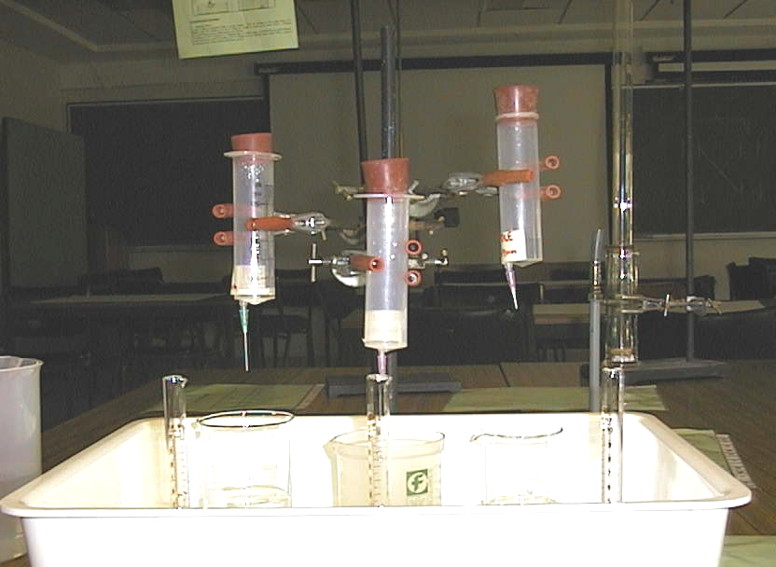
Toothpaste does not flow until a large enough stress is applied. Hence it will sit on a brush without spreading out and dropping off, but can still be squeezed out of the tube easily. Toothpaste and other materials which do not flow until a large force is applied are called plastic, other examples include paint for brushing and sewerage sludge.
η
shear rate
Newtonian
Pseudoplastic
Dilatant

Accompanying sheet

Rheological Materials

Examine the materials supplied.

Which are fluids?
Which are Newtonian fluids?

Measure the flow rates of the fluids and see how the viscosity changes.

