Shoes

Apparatus
old worn shoes, or nothing, students can look at their own shoes.

Action
The students look at their own shoes and each other’s while standing still and while walking. They also examine the pair of worn shoes. The students describe the forces acting on the shoes while standing still and while walking, and try to explain why the shoes are wearing in the way they are.

The Physics
While standing still the shoes are subject to compressive force from the person wearing them. Most materials are very strong to compressive forces. While walking the shoes are also subject to shearing forces, as the foot pushes at the top of the sole (inside the shoe) and the frictional force of the ground acts on the bottom of the sole. In addition the sole is bent as you walk.

mg
N
compressive forces
and shearing forces
compressive
forces only
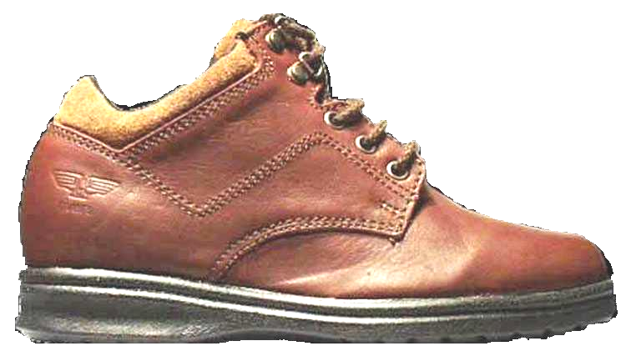

force of ground

force of foot

Accompanying sheet

Shoes

Examine your own shoes and the shoes on display.

What forces are they subject to while standing still?
What about when walking?

Can you find any patterns of wear due to these forces?

