Soap Films

Apparatus
soapy water mix to make soap films ( a little glycerine in the mix helps), wire loop with handle and piece of thread with a loop in it loosely tied across the wire loop, pen or pencil to pierce soap film, selection of wire frames to make bubbles

Action
The students dip the loop into the soapy water mix to produce a soap film across the loop, with the thread and its loop imbedded in the film. They then pierce the film within the loop of thread with a pencil, and observe what happens to the film and thread.

The Physics
When the film inside the inner loop is pierced the outer film is able to contract, pulling the inner loop into a circle, to minimize the surface area of the remaining film. The lowest energy state for a liquid – air interface is that with the smallest surface area.

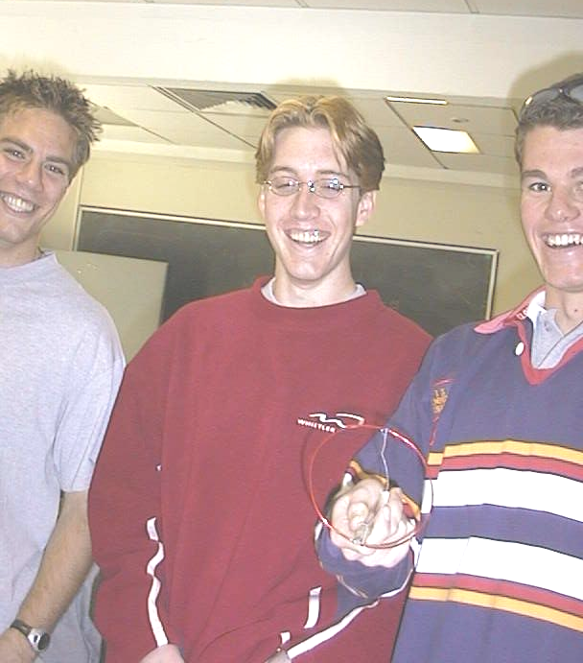

Students with a soap film at the University of Sydney.

Accompanying sheet

Soap Films

Dip the loop in the soapy water to form a film.
Now pierce the film inside the loop of thread.

What happens to the rest of the film? Why?

Experiment with making bubbles.
What do you notice about the surfaces of the bubbles?

