Suction Cups and Magdeburg Plates

Apparatus
suction cups and / or Magdeburg plates with pump to reduce pressure, large sink plungers are also popular with students

Action

The students stick the suction cups to smooth and rough surfaces, and try to determine what makes them stick.
The Magdeburg plates are held together while the air between them is pumped out and students attempt to pull them apart.

The Physics
The force required to pull a suction cup off a surface or the Magdeburg plates apart is proportional to the difference in pressure across the plates/cup and the surface area of the plates/cup.
In order for a suction cup to stick there needs to be lower pressure between the cup and the surface to which it sticks, and it needs to seal against the surface so that the pressure difference is maintained.

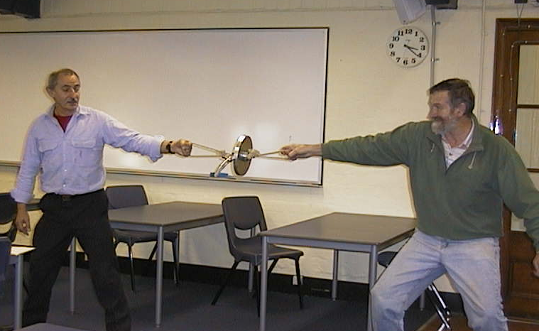

Even two grown men have difficulty separating the Magdeburg plates when the air between them is removed.

Accompanying sheet

Suction Cups and Magdeburg Plates

How can you make the suction cup stick to a surface?
Explain what happens when it sticks and when it fails to stick.

When are the Magdeburg plates hard to pull apart?
When are the Magdeburg plates easy to pull apart? Explain why.

