The Lungs

Apparatus
lung model components: large glass (clear) bottle with bottom cut off, plug with Y-tube inserted into it, 2 balloons, flexible rubber sheet. See picture below.

Action
The students pull the diaphragm on the bottom of the bottle, causing the lungs (balloons) to inflate.

The Physics
When the students pull the diaphragm on the bottom of the bottle down the volume of the bottle increases. This lowers the pressure in the bottle. Inside the balloons it is approximately atmospheric pressure, while outside is now lower. The balloons inflate due to the pressure difference, their volume increases, lowering their internal pressure and drawing air into them. This is how we breathe - increasing the volume of our chest cavity to lower the pressure in our lungs and draw air in.
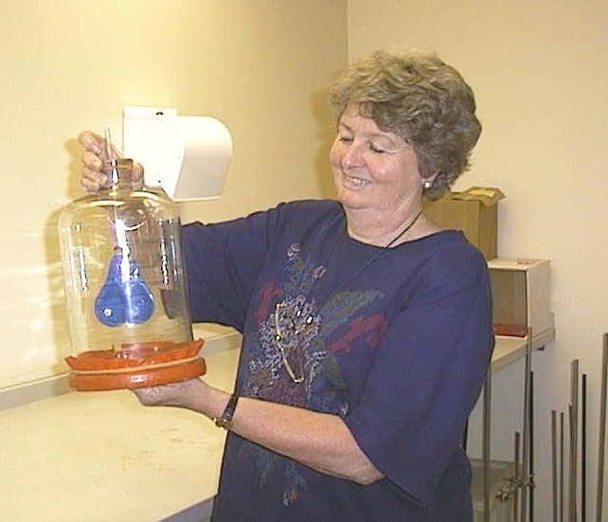
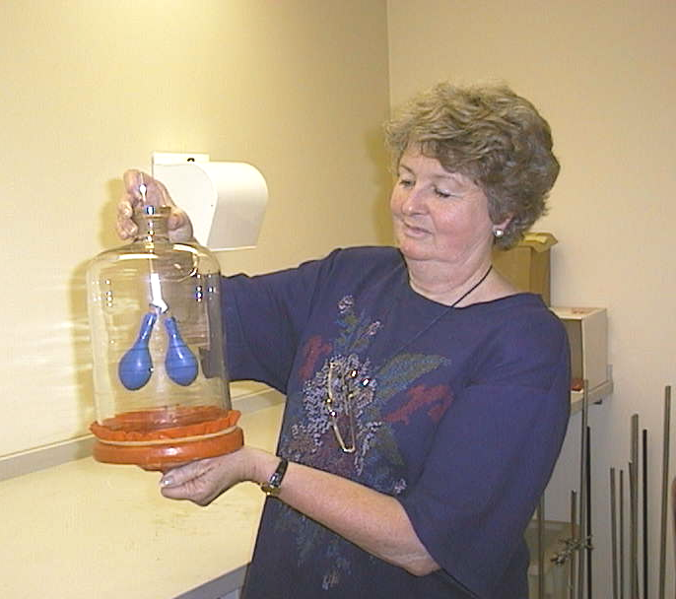

lungs at rest
pull down on the diaphragm and lungs expand

Accompanying sheet

The Lungs

Pull the diaphragm downwards
What do you observe?

What has happened to the pressure in the chest cavity?
What has happened to the pressure in the lungs?

Explain why this has happened.

