Two Sheets of Paper

Apparatus
two pieces of paper, two retort stands with clips to hold the paper
The sheets of paper should be hung parallel, spaced a few centimeters apart.

Action
The students blow between the two pieces of paper. An extension is holding a single piece horizontally and blowing along it so that it rises.

The Physics
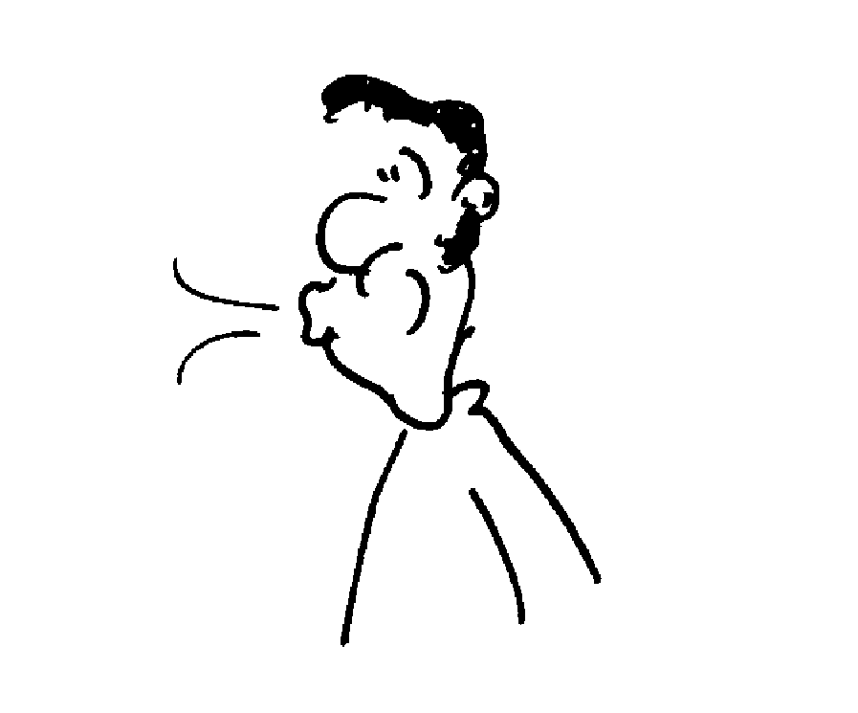
When you blow between the two pieces of paper the air between them is at a higher velocity and lower pressure than the air around them and they are pushed together. This is an application of the Bernoulli effect.
~ 2cm
blow

Accompanying sheet

Two Sheets of Paper

Blow between the sheets of paper.

Explain what you observe.

Where else have you observed this effect?

