Binding Energies

Apparatus
a large chart of the binding energy or mass defect per nucleon

Action
The students examine the chart and identify which nuclei are the most stable and which processes can lead to stability for different nuclei.

The Physics
The most stable nuclei are those with the greatest binding energy per nucleon. Those that are much heavier than iron tend to undergo fission to move back towards the stable region of the chart. Small nuclei like hydrogen can undergo fusion (at high enough temperatures, such as in stars) to form larger elements with greater binding energy per nucleon.

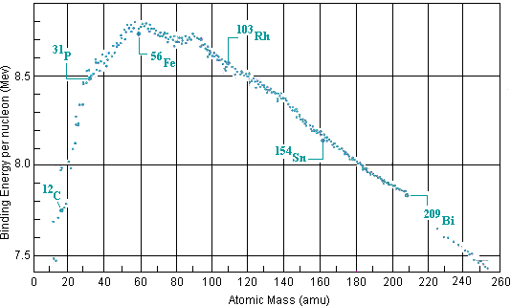

Accompanying sheet:

Binding Energies

Examine the chart of binding energies.
What does the diagram represent?

Fission and fusion are opposite processes,
when fission occurs a nucleus breaks apart
and when fusion occurs two nuclei fuse to form a larger one.
How can both these processes release energy?

Which nuclei are more likely to undergo fusion?
Which will undergo fission? Explain your answer.

