Cathode Ray Tube

Apparatus
working cathode ray tube

Action
The students examine the tube and identify the important components. They should note the similarity to the x-ray tube.

The Physics
The cathode ray tube has a source of electrons (the cathode rays) which are accelerated using an electric potential difference and “steered” using coils. When the electrons collide with phosporus atoms on the screen photons in the visible region are produced. An x-ray tube works in the same way but uses a larger accelerating potential to give the electrons more energy so that x-rays rather than visible photons are released when the target is hit. The target material is usually a metal in an x-ray tube. Old TV sets and oscilloscopes use a phosphorus screen.
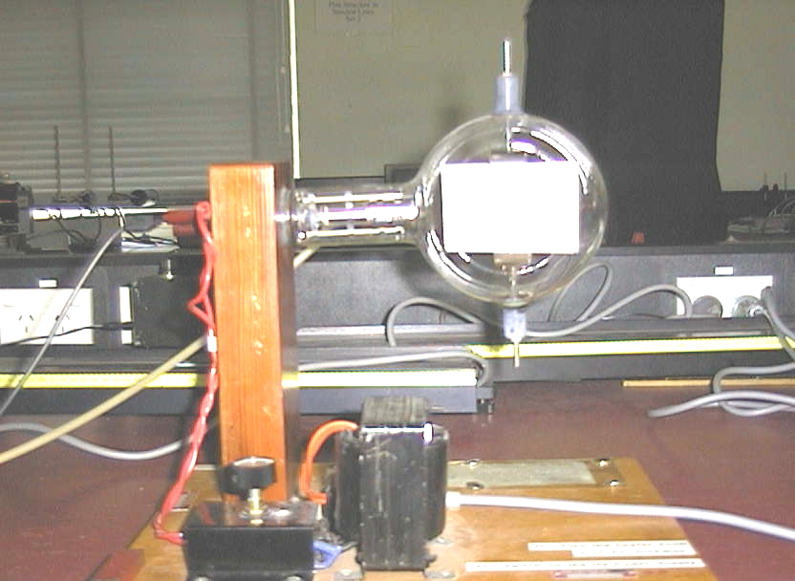

Accompanying sheet:

Cathode Ray Tube

What is a cathode ray?

The cathode ray tube is very like the x-ray tube.

Identify the main components.
How is the cathode ray tube different to the x-ray tube?

