Common Sources of Radiation

Apparatus
some (slightly) radioactive samples and/or laboratory sources, see table below
Mantles for gas lanterns are also an excellent example.

Action
The students measure the radiation from the sources and compare it to the background level.

The Physics
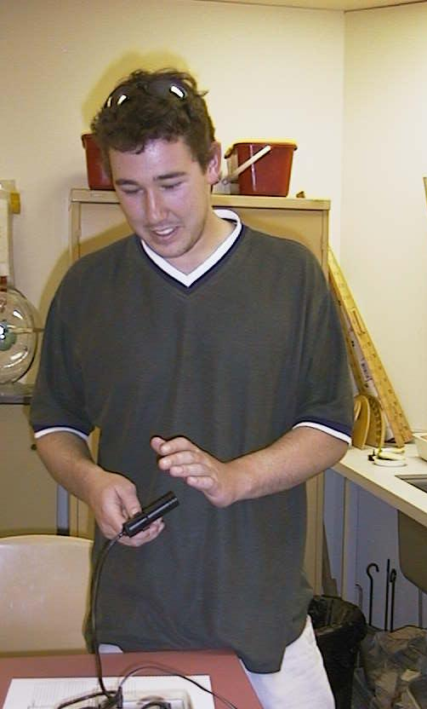
Most of the sources will have levels barely above background. It helps to have a common laboratory source such as Cs for comparison.

Radioactivity in some common substances.
Substance | Activity (Bq/kg)
garden soil | 2000
brazil nuts | 400
human bodies | 80
cows milk | 50
sea water | 12
tap water | 0.1

A student at the Australian Catholic University measuring his own radioactivity.

Dosage limits for ionizing radiation (from the ARPANSA website):
The NHMRC recommended radiation dose limit for the public is 1 mSv (1000 µSv) per year.
ANSTO's dose constraint for reactors, which has been agreed by the Nuclear Safety Bureau, is 100 µSv per year for members of the public

Accompanying sheet:

Common Sources of Radiation

Use the counter to measure the radiation coming from the various sources.

How do they compare to background radiation?
How do they compare to the recommended maximum dosages?

