Electron Interference

Apparatus
photographic plates or diagrams showing an interference pattern due to electron interference

Action
The students look for evidence of the wave and particle nature of electrons in the pictures.

The Physics
In the early pictures individual “dots” are visible, where single electrons have been incident on the plate/detector. The discrete nature of the dots shows the particle nature of electrons.
Waves passing through the slits interfere to give a pattern of fringes, with spacing depending on de Broglie wavelength and slit separation. This is visible in the later pictures and shows the wave nature of the electrons.
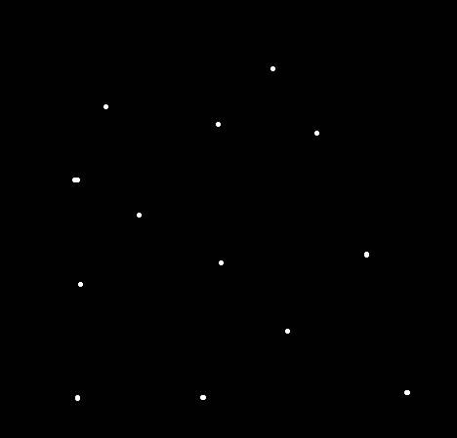
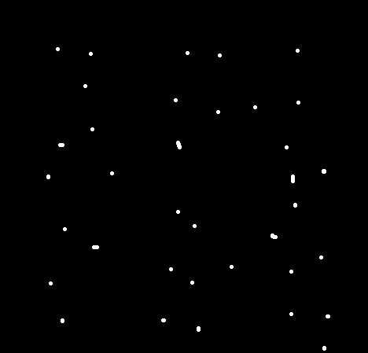
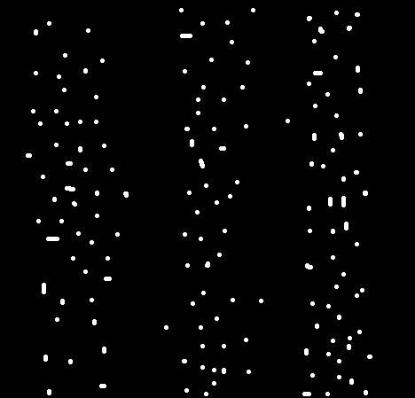
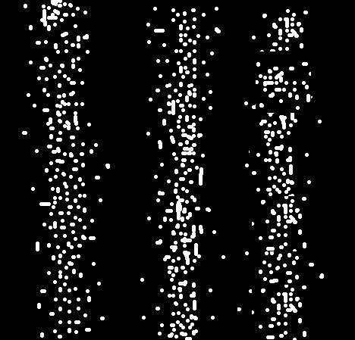
1.
2.
This diagram, or a similar one, showing electron interference can be used.

3.
4.

Accompanying sheet:

Electron Interference

A beam of electrons is directed through two narrowly spaced slits.
The emerging beam falls on a sheet of film.

These pictures contain clear evidence that the electrons are behaving
like ordinary classical particles (tiny billiard balls).

These pictures also contain clear evidence that that the
electrons are behaving like ordinary waves.

