Emission Spectra

Apparatus
hand held spectrometer, light sources

Action
The students observe the spectral lines and compare them for different light sources.

The Physics
The lines correspond to electron transitions, where the emitted photon has the energy difference between the initial and final electron energy level. This energy and hence the wavelength, can be determined using the Bohr model for hydrogen, but is more complicated for larger atoms. It allows the “fingerprinting” of elements by their unique spectra, a valuable tool for finding out what something is made of.
Optometry students at the University of New South Wales observing a sodium spectrum. | 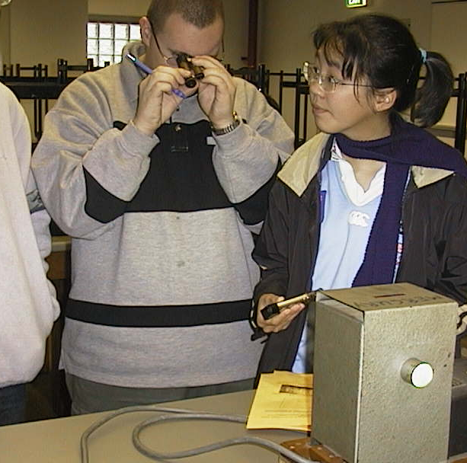

Accompanying sheet:

Emission Spectra

Use the hand held spectroscopes to "look" at light from different sources.

What are the differences in the spectra from the various sources?
Why are the spectra different?

What use can be made of the difference in spectra?

