Hydrogen Spectrum

Apparatus
hand held spectrometer, hydrogen lamp,

Action
The students observe the spectral lines and use Bohr’s model to explain the lines.

The Physics
The lines correspond to electron transitions, where the emitted photon has the energy difference between the initial and final energy level. This energy, and hence the wavelength, can be determined using the Bohr model for hydrogen.
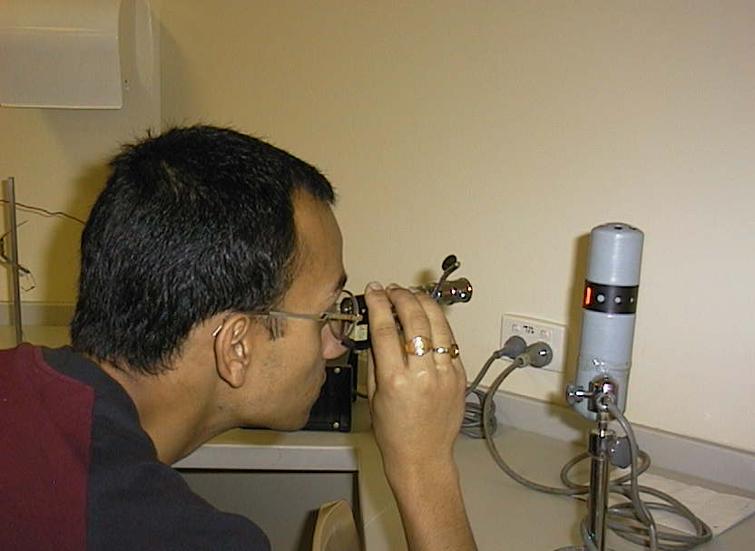

A student at the Australian Catholic University observing a hydrogen spectrum.

Accompanying sheet:

Hydrogen Spectrum

Examine the hydrogen lamp with the naked eye.

Now have a look through the spectroscope.

What do you see?

Sketch the spectra you observe.

