Identify the Element

Apparatus
hand held spectrometer, discharge lamp with label covered or removed, selection of diagrams of spectra for different elements

Action
The students observe the spectral lines and compare them to the diagrams given to identify the element contained in the lamp.

The Physics
The emission spectra for each element is unique, as they all have different energy levels. This provides a way of identifying what elements are contained in an unknown sample.

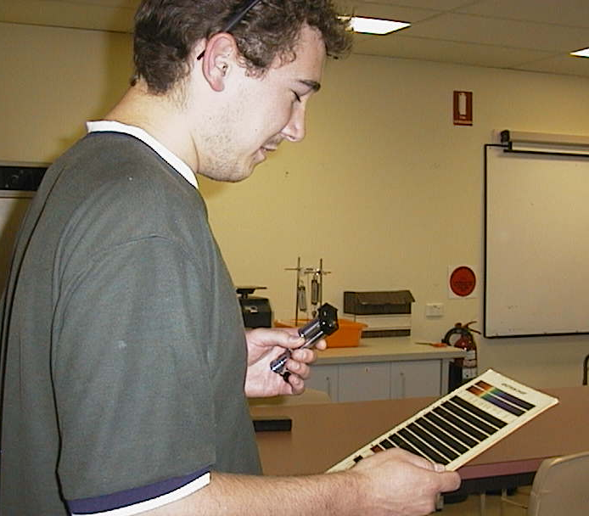
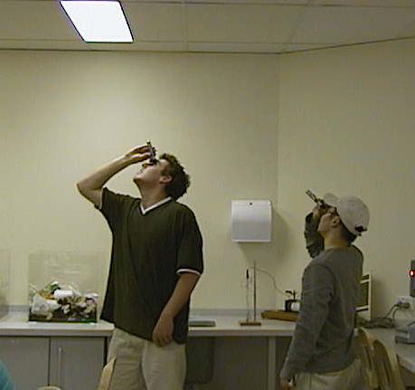

Students at the Australian Catholic University looking at the spectrum of fluorescent lights and using a chart of known spectra to identify the element (mercury) contained in the lights.

Accompanying sheet:

Identify the Element

Use the spectroscope to look at the lamp.

Now use the diagrams of spectra from known samples to
identify the element in the lamp.

What would a spectrum from a sample with several elements look like?

