Measuring Radiation

Apparatus
TLD badges, film badges, Geiger counter or any radiation measuring devices available, sources such as smoke detectors, old gas lamp mantles, old watches with glowing numbers

Action
The students examine the devices and try to explain how they work. They also measure the radiation from various sources.

The Physics
The GM tube in the Geiger counter is filled with low pressure gas, and around +400 Volts are applied to the thin wire in the middle. When a particle enters the tube, it ionizes a gas atom. The electron is attracted to the central wire, and as it rushes towards the wire, it ionizes more gas atoms, giving an ion cascade and creating a pulse which can be amplified and counted.
Radioactivity will darken ("fog") the photographic film in a film badge. The badges have "windows" made of different materials, which block different radiation, so that the dose of α, β and γ can be distinguished.
Scintillation detectors work by the radiation striking a suitable material such as sodium iodide and causing a tiny flash of light, which is picked up by a photo-multiplier tube.
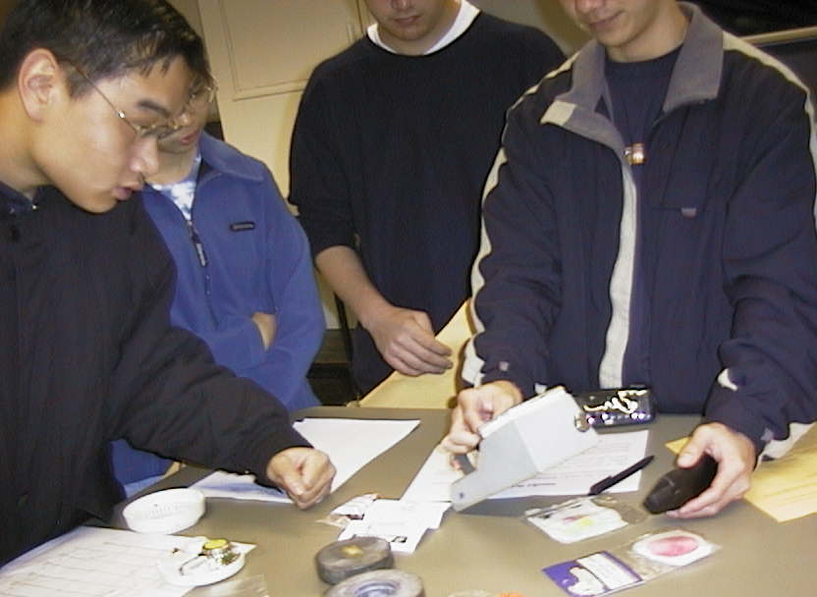

Students at the University of New South Wales using a Geiger counter to measure radioactivity from a mobile phone. Other sources including gas lantern mantles
and a smoke detector are shown.

Accompanying sheet:

Measuring Radiation

Different means of measuring radiation are shown.

Explain how they work.

Which ones would be suitable monitoring devices for
persons working in a radiation area?

