Periodic Table

Apparatus
large chart of the periodic table of the elements

Action
The students look at the table and try to explain the relationship between position and characteristics, such as ionization energy, bonding, etc.

The Physics
The elements are arranged according to their number of outer shell electrons, which is determined by the quantum numbers, (n, l and m) and the Pauli exclusion principle.

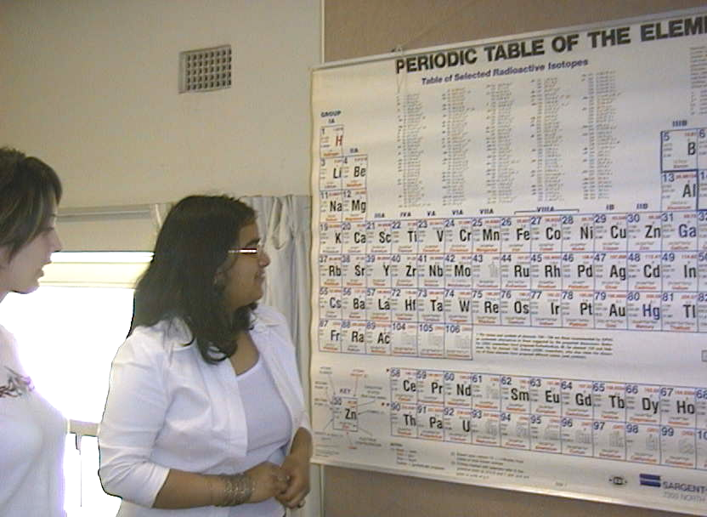

A student at the University of Sydney looking at a periodic table.

Accompanying sheet:

Periodic Table

Examine the chart of the periodic table.

Why are there only 8 elements in both the second and third period?
Shouldn’t there be more in the third?

Why do elements in a given column have similar characteristics?

