Smoke Detector

Apparatus
a battery operated smoke detector, opened up

The smoke detector should be opened up so circuitry is exposed and the warning stickers on the radioactive source visible.

Action
The students examine the smoke detector and identify key components including the ²⁴¹Americium α particle source.

The Physics
The α particles ionize air molecules between two charged plates. The positive ions go to the negative plate, the negative ions to the positive plate, which gives a current. When smoke enters the space between the plates the ions attach themselves to the heavy smoke particles and the flow of current is disrupted, setting off the alarm.
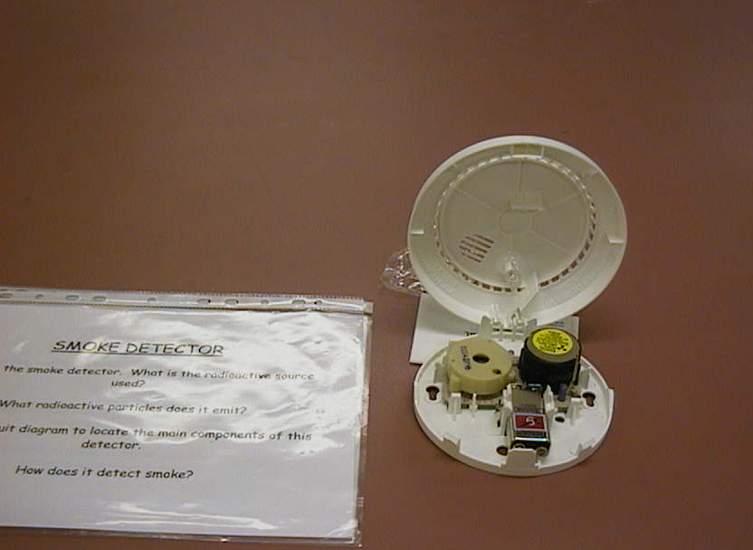

Accompanying sheet:

Smoke Detector

Examine the smoke detector.
It contains a radioactive source, ²⁴¹Americium, which emits 5.4 MeV α particles.

The α particles ionize air molecules between two charged plates.
The positive ions go to the negative plate,
and the negative ions to the positive plate, which gives a current.

How does smoke disrupt the current?
What energy is emitted by the source per second? per day?
How does this compare to acceptable exposure limits?

