Wave and Particle Nature of Light II: Spectral Lines

Apparatus
spectrometer, light source, e.g. a hydrogen lamp

Action
The students observe the spectral lines and try to explain them.

The Physics
Only a single discrete quantum of light, i.e. a photon, is emitted or absorbed during electron transitions. This shows the discrete or particle nature of light.
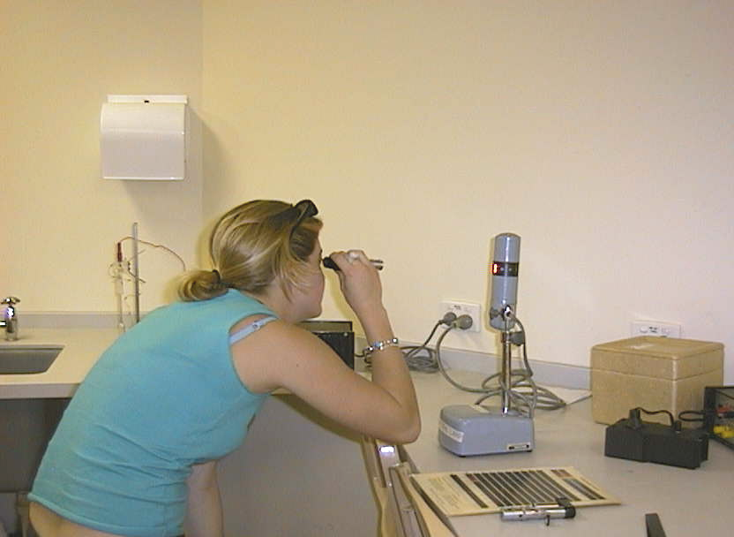

An environmental science student at the Australian Catholic University observing an emission spectrum.

Accompanying sheet:

Wave and Particle Nature of Light II –
Spectral Lines

Use the spectroscope to observe the spectra of the hydrogen lamp.

Why do you observe discrete lines?
What does this experiment tell you about the nature of light?

