X-ray Pictures

Apparatus
two or three x-ray pictures

Action
The students examine the pictures and identify areas of high and low x-ray absorption, and high and low tissue density.

The Physics
X-rays are more strongly absorbed by denser tissues, such as bone. This is because these tissues have a higher proportion of elements with a large number of electrons, which the x-rays interact strongly with. These areas show up white on typical x-ray images, which are negatives.
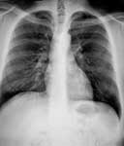

Accompanying sheet:

X-ray Pictures

Examine the x-ray films.

Why are some areas light and others dark?
In which areas are more x-rays absorbed?

Why are more x-rays absorbed in these regions?

