X-ray Tube

Apparatus
Exposed x-ray tube, or opened up x-ray machine showing target and electron source.

Action
The students examine the tube and draw a diagram showing the main components.

The Physics
Electrons are emitted from the filament, and accelerated towards the target. At the target they collide with atoms of the target material and x-ray photons are emitted.

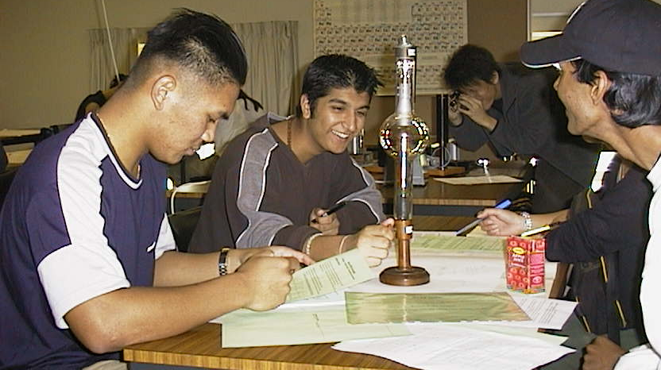

Students at the University of Sydney discussing the workings of an x-ray tube.

Accompanying sheet:

X-ray Tube

Examine the x-ray tube and draw a diagram showing the main components.

Where is the target?

Where and how are the electrons accelerated?

