2D Model of Gases

Apparatus
container with sliding lid containing small balls, e.g. ball bearings or plastic balls, vibrating stand to sit the container on, either upright or on its side

Action
The students examine the equipment and identify the balls as representing gas molecules. They vary the kinetic energy (temperature) of the gas by varying the amplitude of the oscillation. They explain what happens to the pressure and volume of the gas as the temperature is varied.

The Physics
When you increase the “temperature” of the gas the molecules move faster, they have an increased velocity. This means that when they collide with the lid (and walls) of the container they exert a greater pressure, as they can transfer more momentum to the lid. If the lid is not held in place, it will be pushed up, increasing the volume of the container.
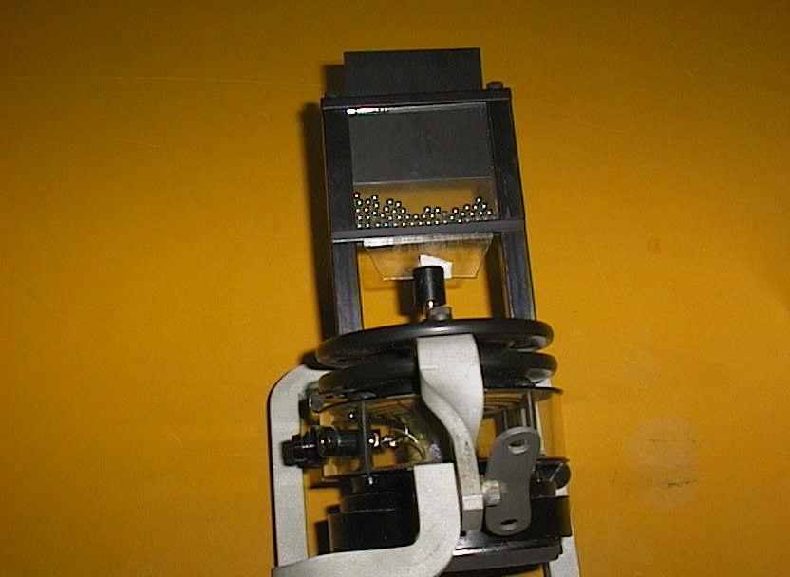

Accompanying sheet

2D Model of Gases

Increase the temperature of the “gas”.

What happens to the pressure?
What happens to the volume if the lid is not fixed?
Explain why this happens.

