Ball Bearings

Apparatus
sealed perspex tube with thermocouple mounted at one end, which can be attached to a digital multimeter or thermometer, very small (~ 5 mm diameter) ball bearings or lead shot to half fill the tube

Action
The students note the temperature of the ball bearing inside the tube with the thermocouple, then disconnect it. They then shake the tube vigorously for a few minutes. (They may want to take turns.) The thermocouple is then reconnected, and they measure the temperature rise of the ball bearings.

The Physics
When you shake the tube you do work on the ball bearings and give them kinetic energy. The kinetic energy is lost as thermal energy, due to friction, as the ball bearings settle again when you stop shaking. This thermal energy increases internal energy of the “ball bearing gas” and the temperature of the ball bearings increases. This is an example of conservation of energy – the change in internal energy = the work done on the system minus the heat lost.
(You could heat up a coffee this way, but it would take years of vigorous shaking.)

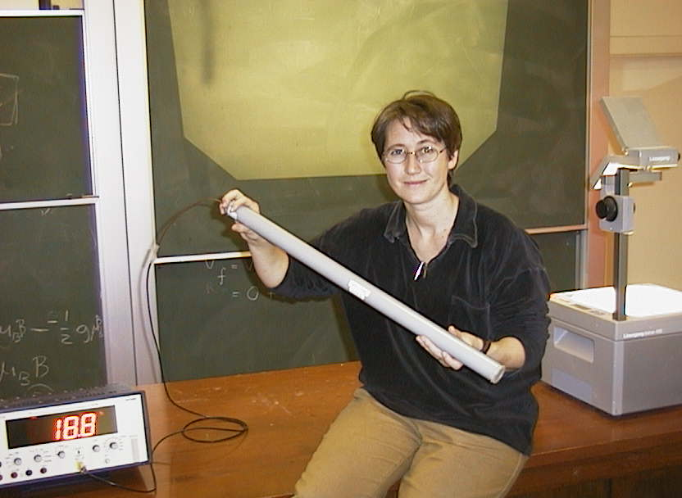

A tutor at the University of Sydney demonstrates the ball bearing tube.

Accompanying sheet

Ball Bearings

Check the temperature of the ball bearings inside of the tube.

Now shake the tube vigorously for a minute or more.

What is the temperature of the ball bearings now?
Why has it changed?

Could you use this technique to reheat a cold cup of coffee?

