Bicycle Pump

Apparatus
bicycle pump or large syringe with thermocouple mounted inside and attached to a digital multimeter or thermometer

Action
The students cover the air nozzle with a finger so that the air cannot escape. They then pump the pump and measure the change in temperature.

The Physics
The air in the sealed off pump is compressed quickly, hence work is done on the air. There is little time for heat transfer to occur, so Q ~ 0, and the change undergone by the gas is a good approximation to an adiabatic process. The increase in internal energy is indicated by the rise in temperature, which is detected by the thermocouple inside the pump. Hence energy is conserved (first law) – the work done is converted to thermal (internal) energy of the air in the pump.

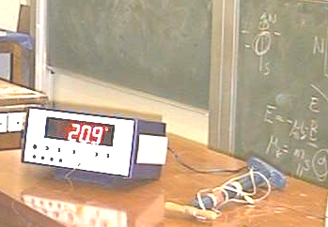

Accompanying sheet

Bicycle Pump

Note the temperature of the air inside the pump.
Put your finger on the end of the nozzle so that the air in the pump is trapped.

Pump the bicycle pump and feel what happens to the cylinder.

Measure the change in temperature.
Explain your observations using the first law of thermodynamics.

