Boyle’s Law

Apparatus
Boyle’s law apparatus: a hand or foot pump connected to a column of oil and a pressure gauge. It helps to have a valve fitted between the pump and column/gauge so that the students can pump to a given pressure, then close the valve to keep the pressure constant while they take a reading.

Action
The students pump with the valve open, increasing the pressure and pushing the oil column upwards. This compresses the air above. They pause a few times, close the valve, and take a pressure and volume reading of the air above the oil.

The Physics
The pressure is transmitted evenly through the oil, compressing the air above. The volume of the air decreases as pressure increases.
Boyle’s law states that volume varies inversely with pressure, (P ∝ $\frac{1}{V}$) however there may be small differences due to experimental error. This is a special case of PV = nRT, when T, and n are held constant.

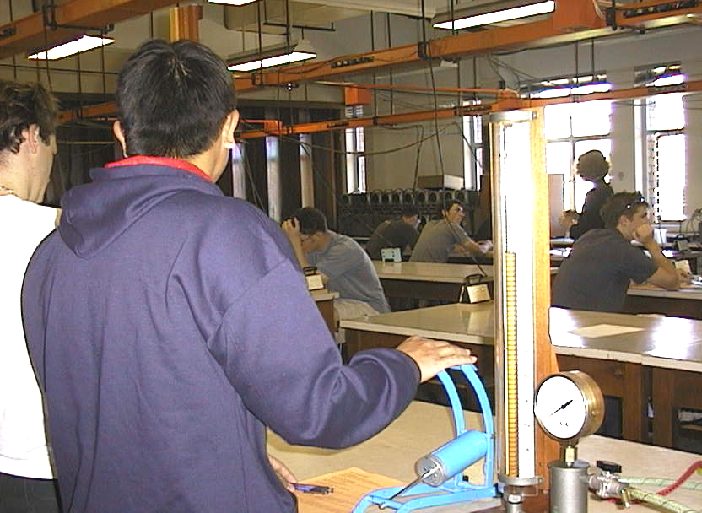

Students at the University of New South Wales using the Boyle’s law apparatus.

Accompanying sheet

Boyles Law

Use the pump to apply pressure to the oil column.
What happens as you increase the pressure?
What is happening to the volume of air above the oil?

Take a four or five readings of pressure and volume.
How does volume vary with pressure?
Sketch a graph of volume as a function of pressure.

