Measuring Air Temperature

Apparatus
thermometers, lamp or sunny area

Action
The students use the thermometers to measure air temperature in the sun and in the shade. They should compare the two readings and explain why they are so different even though the air temperature is not much different. They should try to explain what (literally) a thermometer is measuring the temperature of.

The Physics
A thermometer always measures its own temperature. If it is in the shade, it reaches thermal equilibrium with the surrounding air molecules and measures that temperature. When heated by the sun's radiation it measures its own raised temperature. The equilibrium temperature is greater than the air temperature because the thermometer is being heated by absorbing more heat from radiation. Hence the thermometer under the light is not measuring air temperature, only its own temperature.
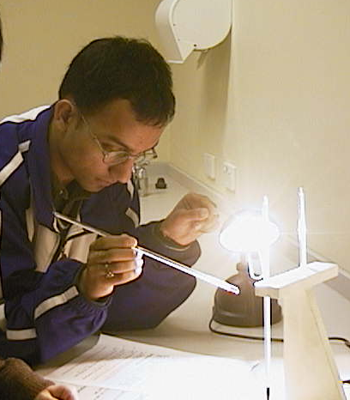

A student at the Australian Catholic University using a thermometer to measure temperature in front of a light.

Accompanying sheet

Measuring Air Temperature

Check the readings on the two thermometers.

Now put one of them under the light or in the sun for a few moments.

How do the readings compare now?
What does a thermometer actually measure?

