Stirling Engine

Apparatus
small working Stirling engine

Action
The students set the engine going and observe the cycle. The students are provided with a schematic drawing of the Stirling cycle. They should try to follow the cycle on the real engine, and identify the heat reservoirs. They then draw p-V diagrams for the four stages. Note – specific instructions for individual engines may be necessary. (An addition schematic diagram is included on the next page.)

The Physics
There are four processes in the Stirling cycle:
1. Isothermal expansion at T_{H}. Left piston moves down and heat Q_{H} is transferred to the gas from the left cylinder wall, which is kept hot by the heat reservoir at T_{H}.
2. Constant volume process – temperature decreases from T_{H} to T_{C} as hot gas passes through the wire mesh. The gas heats the mesh. The volumes change by equal amounts.
3. Isothermal compression at T_{C} back to original volume. Heat Q_{C} is lost from the gas on the right hand side to the cold reservoir.
P
V
P
V
P
V
3
P
V
4
1
2
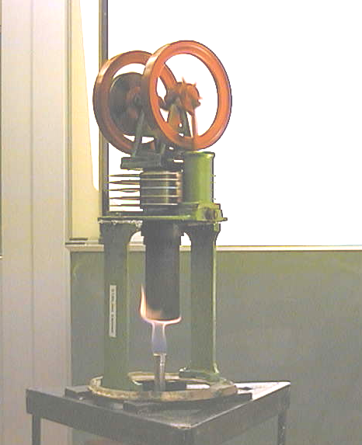
4. Constant volume process – temperature increases from T_{C} to T_{H}, cold gas is pushed across the hot wire mesh and the changes in volume of the two cylinders are equal.

Accompanying sheet

Stirling Engine

Set the Stirling engine running.

Examine the Stirling engine and compare the up and down strokes of the engine
to the four stages of the Stirling cycle on the schematic diagram.

Draw p-V diagrams for the four stages.

Diagram of Stirling cycle - can be enlarged and included with instruction sheet for students to refer to.

T_{H}
T_{C}
Q_{H}
T_{H}
T_{C}
gas flow
T_{H}
T_{C}
Q_{C}
T_{H}
T_{C}
gas flow
1. expansion stroke
2. constant volume
3. compression stroke
4. constant volume

