Thermal Conductivity

Apparatus
blocks of wood or plastic, polystyrene, metal or glass, multimeter with thermocouple or digital thermometer with probe, masking tape

Action
The students feel each block and rank the blocks in term of warmest to coldest. They then measure the temperature of each block by taping the probe to each block in turn.
Note that the blocks shouldn’t be handled too much or they can warm up from the students hands.

The Physics
Many students are surprised to find that the blocks are all at the same temperature (within a small range). The blocks are all at room temperature, as they are in thermal equilibrium with the air in the room. Your skin is usually a little warmer than room temperature, and when you touch something like metal it feels cold because heat is quickly conducted away from the skin by the metal. Wood and polystyrene are good insulators, and do not conduct heat away from your skin, hence they feel warm. What are you are really feeling when you feel for “temperature” is the rate at which heat is transferred to or from your skin. Hot water feels hotter than air of the same temperature and will burn when air will not.
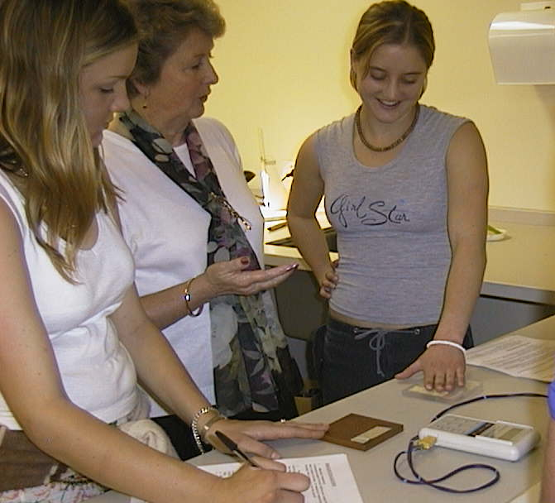

Students at the Australian Catholic University comparing the thermal conductivity of different materials.

Accompanying sheet

Thermal Conductivity

Feel the different blocks.
Which feels the coldest? Which feels the warmest?

Now measure their temperatures.
Which is the warmest? Which is the coldest?
Explain your observations.

