Thermal Expansion of Solids – Bimetallic Strip

Apparatus
bimetallic strip clamped on a retort stand, hair dryer or hot glue gun or some other (safe) means of heating the strip

Action
The students heat the strip and observe what happens to it. They should try to explain their observations and give an example of how such a strip could be used.

The Physics
The bimetallic strip is made of two metal strips, stuck together. One of the metals expands much more than the other when they are heated. This causes the strip to bend. A bi-metallic strip can be used as a sensor in a thermostat. When the strip starts to get hot, it will bend, and can be used as a switch which either closes or opens a circuit as it bends to or away from a contact.

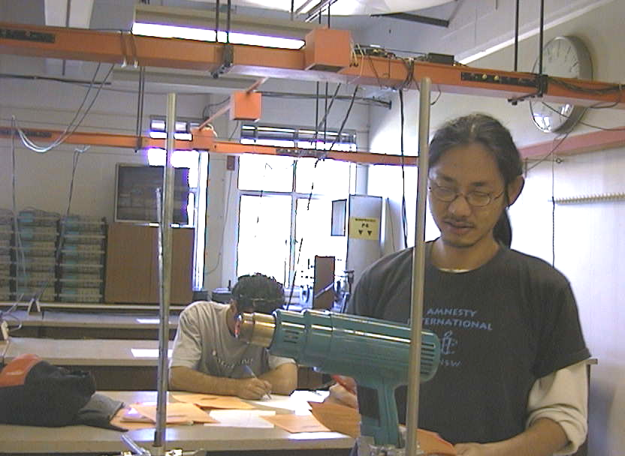
bimetallic strip bent due to heating

Accompanying sheet

Thermal Expansion of Solids – Bimetallic Strip

Heat the strip using the hot air gun.

What happens to the strip, and why?

Can you think of a use for such a strip?

