Thermal Radiation – the Leslie Cube

Apparatus
thermopile (infrared detector), a Leslie cube on a stand, thermometer with thermocouple or probe
A Leslie cube is a hollow metal cube with claddings of different types – for example a painted shiny black side, a painted matt black side, a shiny metal side and a dull metal side. The cube should have a lid on top and be filled with very hot water (boiling water if possible).

Action
The students aim the thermopile at the different sides of the cube and see which side radiated the most. They can measure the temperature of each side to confirm that they are all at the same temperature.

The Physics
The greater the emissivity, ε, of the surface the more it will radiate for a given temperature. The quantity ε takes values between 0 and 1 depending on the nature of the surface radiating heat, a perfect radiator of heat has ε = 1 and is called a blackbody radiator. To a good approximation, all the sides (surfaces) of the cube are at the same temperature - the cube contains hot water and the cube’s sides are made of thin sheet metal, a good conductor of heat. The surfaces with the greater emissivity – matt black, shiny black (in that order) will radiate the most and have $e»1$ whereas shiny, polished metal (like a new stainless steel kettle) may have $e»0$.

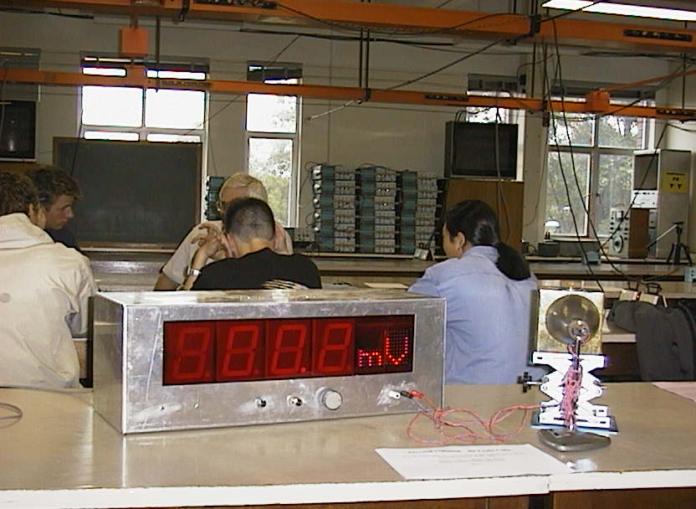
Thermopile detector in front of the Leslie cube in a workshop tutorial at the University of New South Wales

Accompanying sheet

Thermal Radiation – the Leslie Cube

Check the temperatures of the different sides to see that they are the same.

Now use the thermopile detector to measure
the radiant heat from the different surfaces of the cube.

Which surface radiates the most?
Which surface radiates the least?
Why?

