Thermometers

Apparatus
a selection of thermometers including digital thermometer, liquid in glass for people or fish tank, liquid in glass for confectionary or baking, and whatever else is available, for example constant volume gas thermometer, colour changing strips.

Action
The students examine the various thermometers and take some temperature readings. They should identify (if possible) what physical property, which changes with increasing temperature, is used by the various thermometers. They should also try to identify when such a thermometer might be used.

The Physics
A liquid in glass thermometer uses the thermal expansion of a liquid to measure temperature. The scale is calibrated to read the temperature as a function of the volume of the liquid. The coefficient of expansion of the liquid and the room available for expansion determine the temperature range that the thermometer is used for. A “people” thermometer is very accurate, but reads over a small range of temperatures. A confectioners thermometer reads to very high temperatures, but is not very accurate.
Constant volume gas thermometers use the thermal expansion of a gas, which results in increasing pressure as the volume of the gas is fixed. The pressure then tells you the temperature.
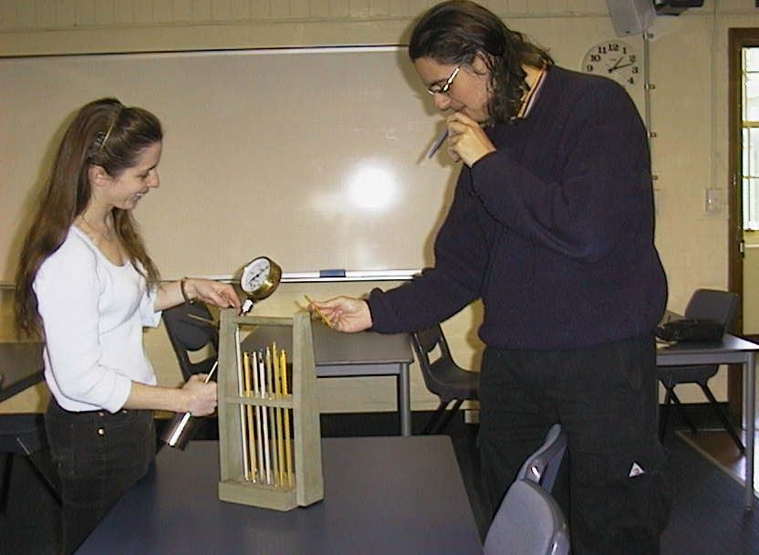
Digital thermometers use a change in electrical resistance with temperature. There are two types – those that have an increasing resistance with increasing temperature, and those that have a decreasing resistance with increasing temperature. The change in resistance is determined by the material the sensor is made out of. (This is covered in more detail in the thermocouples and thermistors activity in the Quantum, Atomic and Nuclear section.)

Students at the University of Sydney examining a range of thermometers.

Accompanying sheet

Thermometers

Examine the different thermometers on display.

What physical property do they use to measure temperature?

What would you use these thermometers for?

