Water Boiling at less than 100º C

Apparatus
large syringe containing warm water (hot tap water)

Action
The students close the end of the syringe and pull back on the plunger rapidly. This will cause the water inside to boil and bubbles will be visible.

The Physics
Boiling happens when evaporation occurs beneath the surface of a liquid, forming bubbles of vapour which rise to the surface and escape. The pressure inside a bubble has to be equal to the pressure outside for the bubble to exist. The pressure outside the bubble depends on the temperature of the water and the pressure above the liquid. If you decrease the atmospheric pressure then the pressure required inside the bubble lowers and the molecules in the liquid don’t need to move as fast to exert this pressure on the bubble. So the boiling point decreases.
When the syringe is pulled suddenly, the volume increases, so pressure decreases and boiling point decreases.
At high altitudes where the atmospheric pressure is lower the boiling point of water is lower.
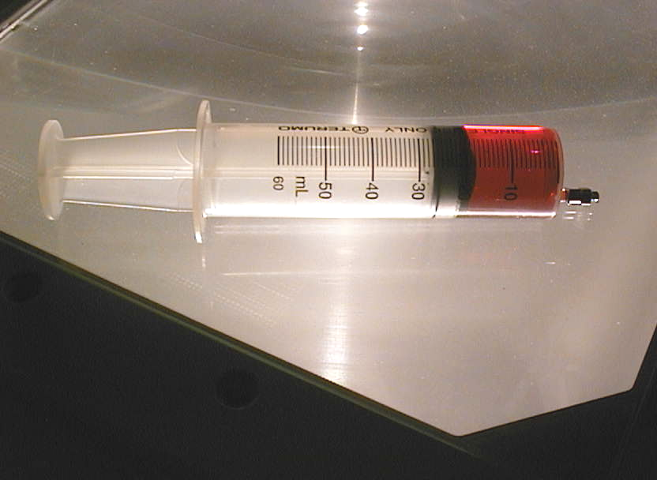
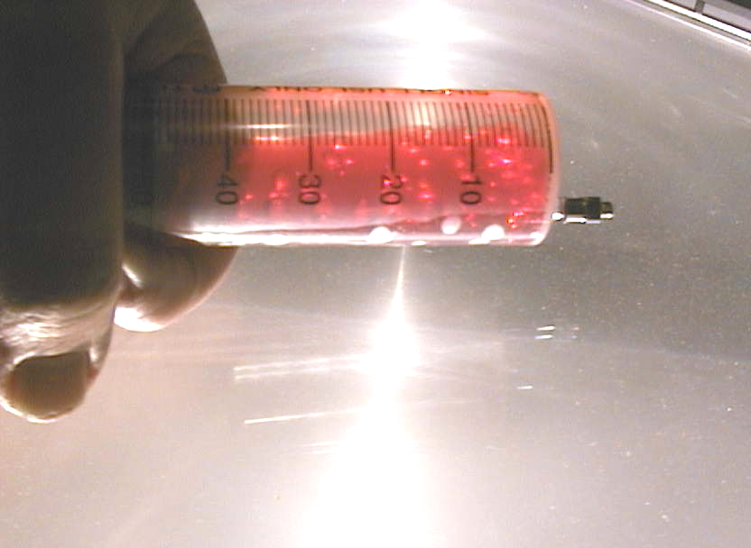

The syringe contains water and food colouring so that the bubbles are easier to see. The water boils, forming bubbles when the plunger is pulled causing a drop in pressure.

Accompanying sheet

Water boiling at less than 100º C

Close the end on the syringe by holding your thumb or a bit of cloth over it.

Now pull the plunger back rapidly.

What do you observe?
Why does this happen?
What happens to the boiling point of water at high altitudes?

